WJ Art News

Semester 2 2012

Questions? Comments. Concerns.
Email me at: agravlin@west-jefferson.k12.oh.us or Call me at: 614-879-7681
Work will be returned to take home next week.
Check out Artsonia.com
Dates to Remember:
May 18th Seniors Last Day!
Final Projects Due!
May 25th Students last full day. Final Projects Due!
Finals: May 29, 30, 31
My room is open during these days for you to complete your work! If needed. You do not need to come in during my finals if your project is complete.

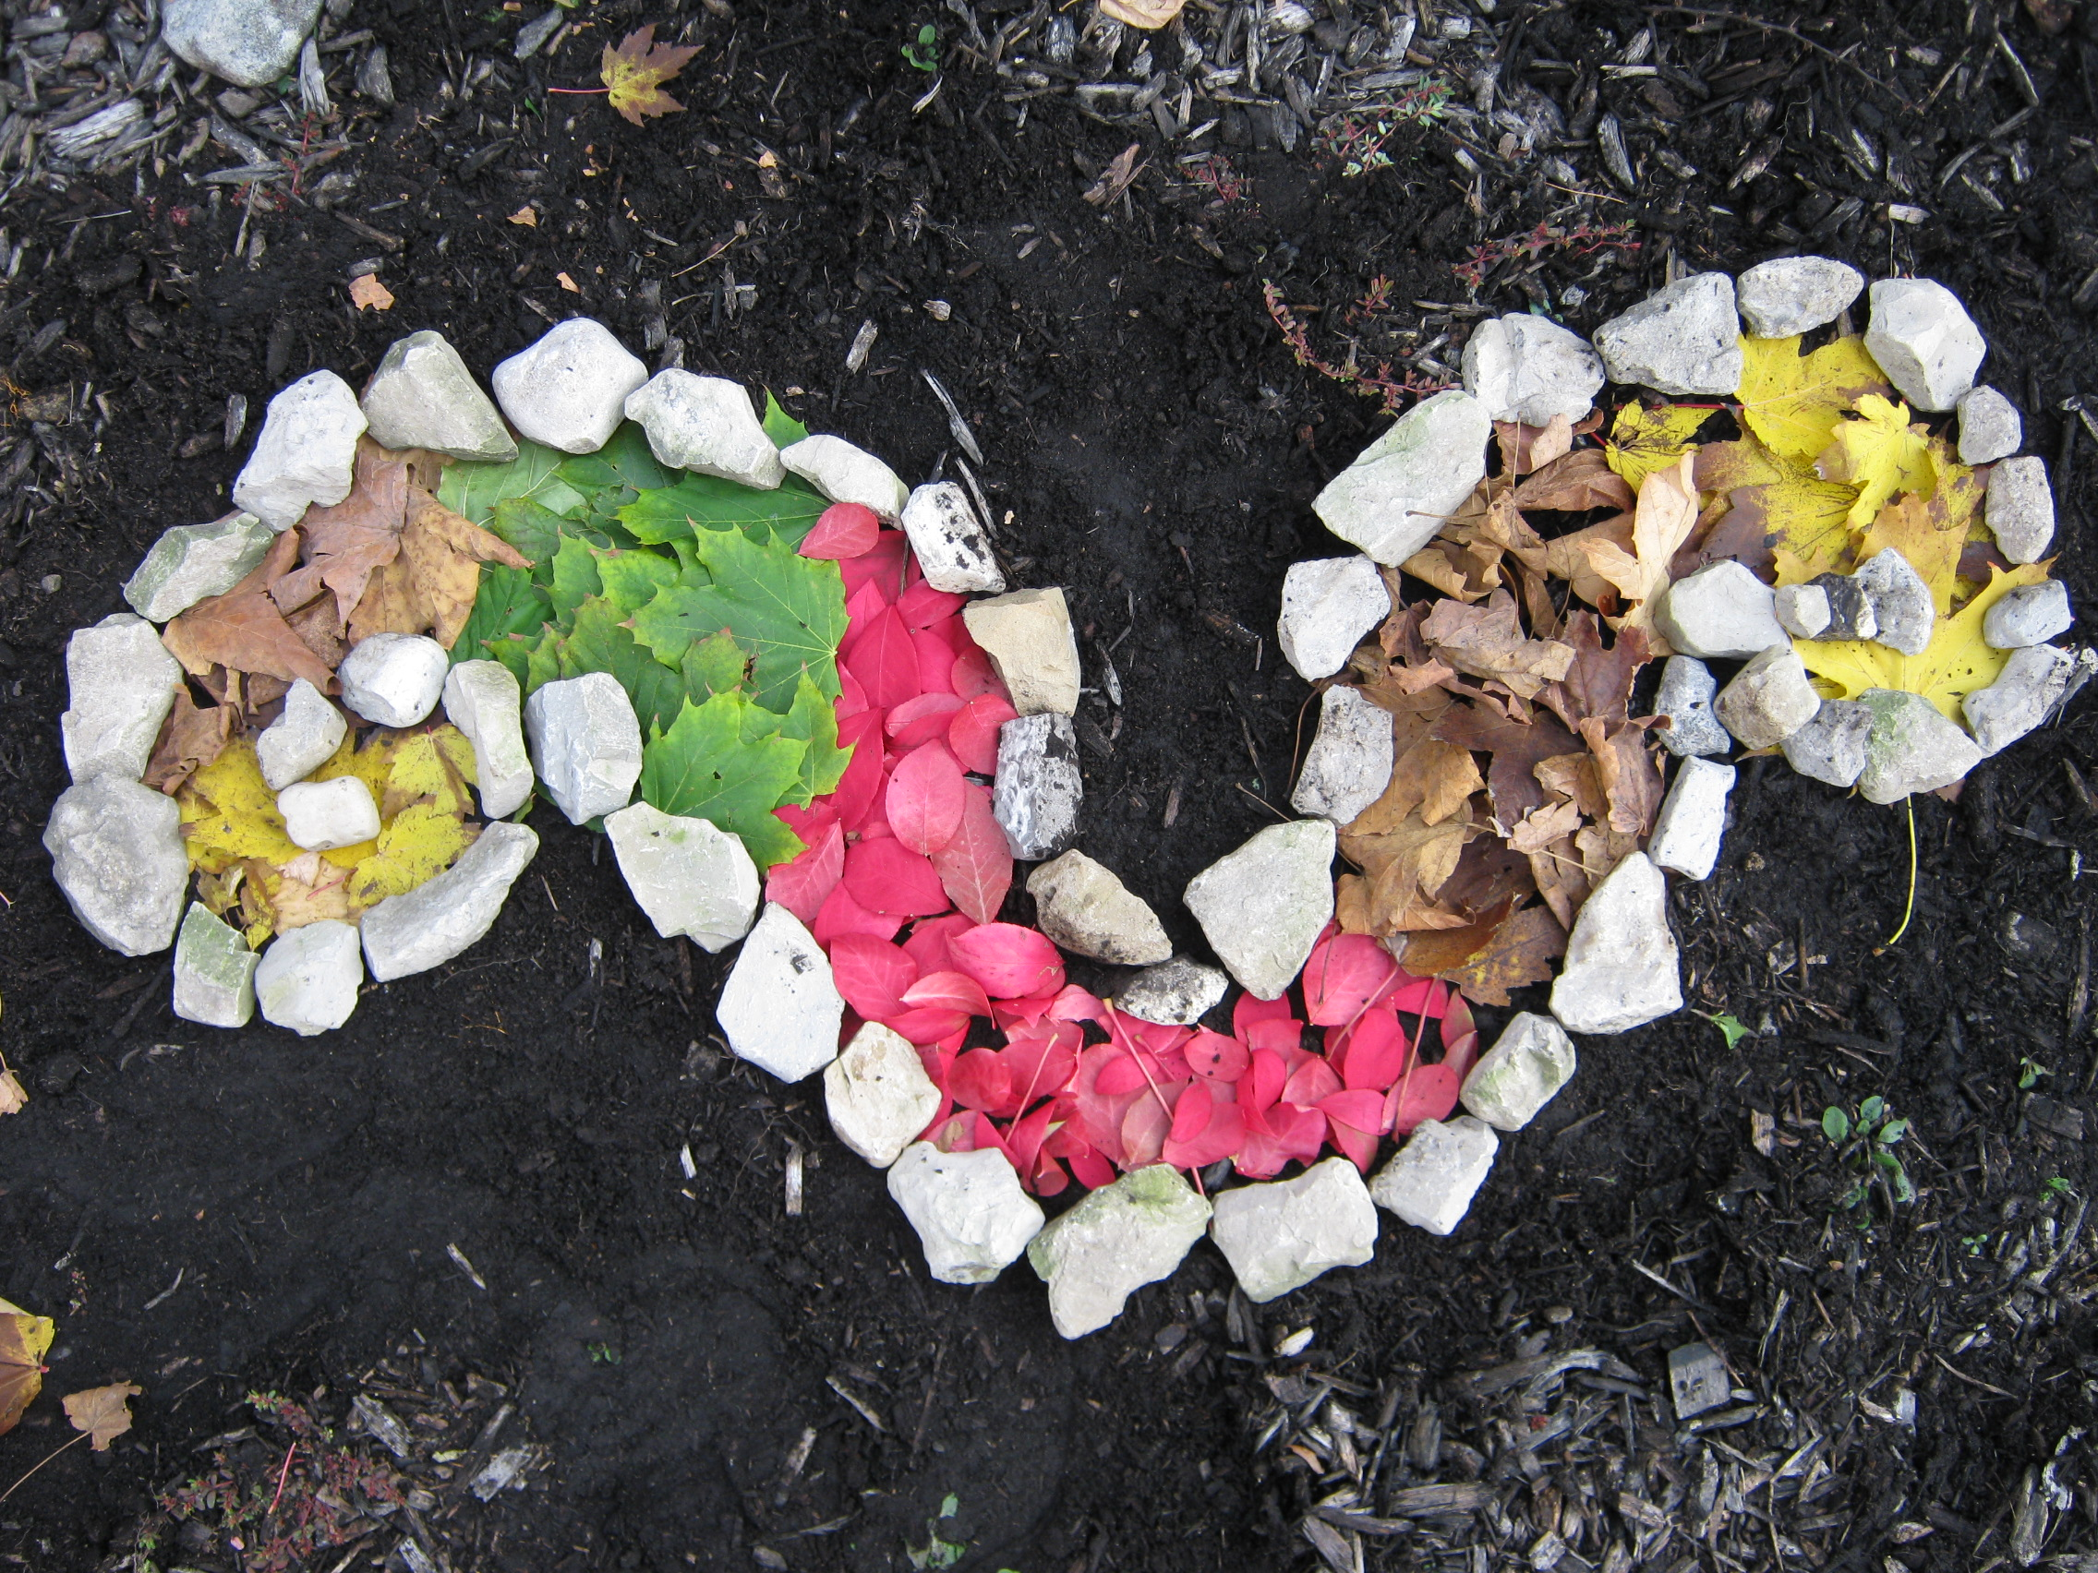

Concepts we have learned about….

Art 1 & 2
http://wjhsartwithmrsg.pbworks.com/w/page/4 7270946/FrontPage?email=agravlin%40west-jefferson.k12.oh.us

Painting
Ceiling tiles! http://www.artsonia.com/schools/school.asp?id=100941

Ceramics 1
The final will be a themed teapot. Plus they will get a chance to throw on the pottery wheel.
Ceramics 2
Great job at Feats of clay! Finals are extra-large vases, bowls, cups, lanterns, etc.

Art History
Final is open!

Digital Photo

Amazing work from these students still life’s, color and light, portraits, & textures and patterns. Check out the shutterfly link. http://wjdigitalphotographyclass.shutterfly.com/
Ask your student for the password.
We are working on speed, collections and photo essays soon.


